Sterility hump in Cows: a condition associated with Cystic ovarian degeneration

Animal Breeding Group, NDDB, Anand
Sterility hump is observed in cows having chronic cystic ovarian degeneration problem. In affected cows, the tail is raised because of relaxation of pelvic ligaments due to chronic exposure to estrogn hormone, which gives an appearance of hump. As the condition is mostly seen with chronic follicular cyst, other signs associated with follicular cyst are also evident in cows with sterility hump.
Predisposing factors:
There are several factors leads to sterility hump
- Follicular cyst due to single or multiple unovulatory follicles, on one or both ovaries
- Cows in 2 to 5 lactation are more prone within 1st to 4th month of parturition.
- Failure to ovulation due to insufficient LH level or less responsive LH receptors
- Predisposition due to heredity
- Nutritional imbalance like high protein diet (particularly high in soluble protein) and deficiency in Selenium
- Postpartum uterine infection
- Prolonged feeding with estrogenic fodder like, Alfa alfa, red clover, pea silage etc.
- High milk production
Clinical signs:
- Nymphomania along with aggressive sexual behavior (referred as “Buller”)
- Relaxation of sacrociatic ligaments and upward displacement of coccygeal bones leading to tipping of pelvis.
- Aggressive sexual behavior may cause hip dislocation and pelvic fracture.
- Tough, tenacious and opaque mucus discharge during estrus
- Increased incidence of pneumovagina and urovagina
- Tendency of vaginal prolapse due relaxation of ligament
- In chronic cases, the cow becomes heavy, coarse and thick necked like a steer due to prolonged gonadal steroid stimulation (Adrenal virilism)
- In rectal palpation multiple cysts in one or both the ovaries and relaxed pelvic ligaments is observed.
- Hydrometra and mucometra in chronic cases
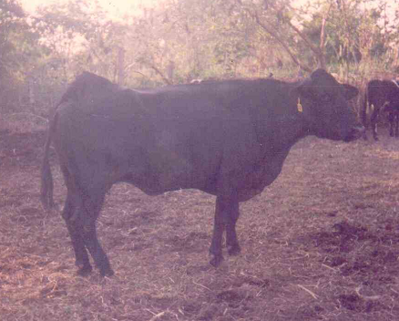
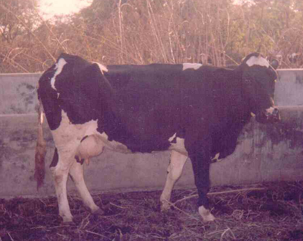

Fig. 1 HF crossbred cow showing sterility hump condition
Treatment:
A qualified veterinarian should examine the suspected animal and he should only attempt treatment.
Management:
To avoid this condition farmer must give emphasis to the following
- Balanced ration, with special consideration to the amount of soluble protein
- Mineral mixture supplementation with special consideration to Selenium.
- Prolonged Feeding with estrogenic plants should be avoided.
- Conditions like endometritic, pyometra and metritis should be treated at earliest to avoid cystic condition.
Compiled by Dr. N. K. Nanote, Manager (AB), NDDB, Chandigarh

